> require(ISLR)

Loading required package: ISLR

> names(Smarket)

[1] "Year" "Lag1" "Lag2" "Lag3" "Lag4" "Lag5"

[7] "Volume" "Today" "Direction"

> summary(Smarket)

Year Lag1 Lag2 Lag3

Min. :2001 Min. :-4.922000 Min. :-4.922000 Min. :-4.922000

1st Qu.:2002 1st Qu.:-0.639500 1st Qu.:-0.639500 1st Qu.:-0.640000

Median :2003 Median : 0.039000 Median : 0.039000 Median : 0.038500

Mean :2003 Mean : 0.003834 Mean : 0.003919 Mean : 0.001716

3rd Qu.:2004 3rd Qu.: 0.596750 3rd Qu.: 0.596750 3rd Qu.: 0.596750

Max. :2005 Max. : 5.733000 Max. : 5.733000 Max. : 5.733000

Lag4 Lag5 Volume Today

Min. :-4.922000 Min. :-4.92200 Min. :0.3561 Min. :-4.922000

1st Qu.:-0.640000 1st Qu.:-0.64000 1st Qu.:1.2574 1st Qu.:-0.639500

Median : 0.038500 Median : 0.03850 Median :1.4229 Median : 0.038500

Mean : 0.001636 Mean : 0.00561 Mean :1.4783 Mean : 0.003138

3rd Qu.: 0.596750 3rd Qu.: 0.59700 3rd Qu.:1.6417 3rd Qu.: 0.596750

Max. : 5.733000 Max. : 5.73300 Max. :3.1525 Max. : 5.733000

Direction

Down: 602

Up: 648

> pairs(Smarket,col=Smarket$Direction)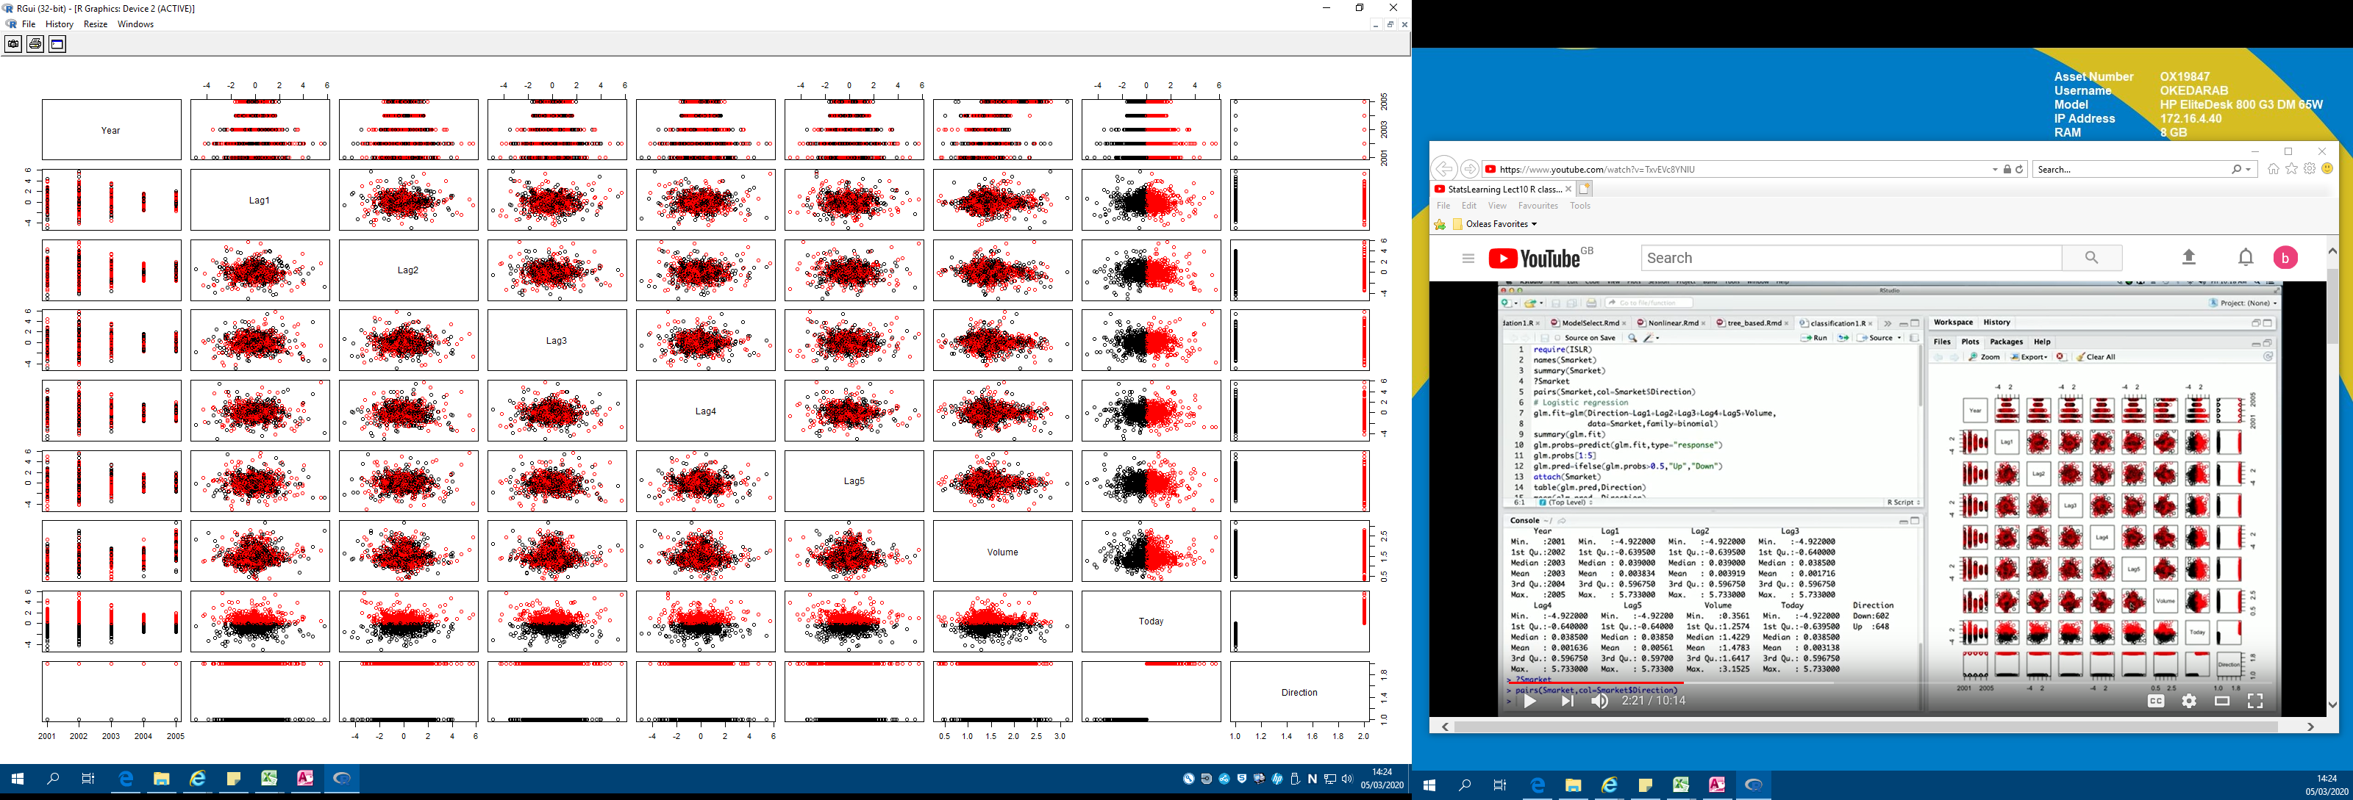

> glm.fit-glm(Direction~Lag1+Lag2+Lag3+Lag4+Lag5+Volume,data=Smarket,family=binomial)

Error in glm.fit - glm(Direction ~ Lag1 + Lag2 + Lag3 + Lag4 + Lag5 + :

non-numeric argument to binary operator

> glm.fit=glm(Direction~Lag1+Lag2+Lag3+Lag4+Lag5+Volume,data=Smarket,family=binomial)

> summary(glm.fit)

Call:

glm(formula = Direction ~ Lag1 + Lag2 + Lag3 + Lag4 + Lag5 +

Volume, family = binomial, data = Smarket)

Deviance Residuals:

Min 1Q Median 3Q Max

-1.446 -1.203 1.065 1.145 1.326

Coefficients:

Estimate Std. Error z value Pr(>|z|)

(Intercept) -0.126000 0.240736 -0.523 0.601

Lag1 -0.073074 0.050167 -1.457 0.145

Lag2 -0.042301 0.050086 -0.845 0.398

Lag3 0.011085 0.049939 0.222 0.824

Lag4 0.009359 0.049974 0.187 0.851

Lag5 0.010313 0.049511 0.208 0.835

Volume 0.135441 0.158360 0.855 0.392

(Dispersion parameter for binomial family taken to be 1)

Null deviance: 1731.2 on 1249 degrees of freedom

Residual deviance: 1727.6 on 1243 degrees of freedom

AIC: 1741.6

Number of Fisher Scoring iterations: 3

> glm.probs=predict(glm.fit,type="response")

> glm.probs[1:5]

|  |  |  |  |  |
| --- | --- | --- | --- | --- |
| 1 | 2 | 3 | 4 | 5 |
| 0.5070841 | 0.4814679 | 0.4811388 | 0.5152224 | 0.5107812 |

> glm.pred=ifelse(glm.probs>0.5,"Up","Down")

> attach(Smarket)

> table(glm.pred,Direction)

|  |  |  |  |
| --- | --- | --- | --- |
|  | Direction |  |  |
| glm.pred |  | Down | Up |
|  | Down | 145 | 141 |
|  | Up | 457 | 507 |

> mean(glm.pred==Direction)

[1] 0.5216

> # Make training and test set

> train = Year<2005

>glm.fit=glm(Direction~Lag1+Lag2+Lag3+Lag4+Lag5+Volume,data=Smarket,family=binomial,subset=train)

> glm.probs=predict(glm.fit,newdata=Smarket[!train,],type="response")

> glm.pred=ifelse(glm.probs >0.5,"Up","Down")

> Direction.2005=Smarket$Direction[!train]

> table(glm.pred,Direction.2005)

|  |  |  |  |
| --- | --- | --- | --- |
|  | Direction.2005 |  |  |
| glm.pred |  | Down | Up |
|  | Down | 77 | 97 |
|  | Up | 34 | 44 |

> mean(glm.pred==Direction.2005)

[1] 0.4801587

> # This model is predicting worse, so we may have overfit the data. So will fit a smaller model

> # Fitting smaller model

> glm.fit=glm(Direction~Lag1+Lag2,data=Smarket,family=binomial,subset=train)

> glm.probs=predict(glm.fit,newdata=Smarket[!train,],type="response")

> glm.pred=ifelse(glm.probs >0.5,"Up","Down")

Error: unexpected '>' in ">"

> glm.pred=ifelse(glm.probs >0.5,"Up","Down")

> table(glm.pred,Direction.2005)

|  |  |  |  |
| --- | --- | --- | --- |
|  | Direction.2005 |  |  |
| glm.pred |  | Down | Up |
|  | Down | 35 | 35 |
|  | Up | 76 | 106 |

> mean(glm.pred==Direction.2005)

[1] 0.5595238

> summary(glm.fit)

Call:

glm(formula = Direction ~ Lag1 + Lag2, family = binomial, data = Smarket,

subset = train)

Deviance Residuals:

Min 1Q Median 3Q Max

-1.345 -1.188 1.074 1.164 1.326

Coefficients:

Estimate Std. Error z value Pr(>|z|)

(Intercept) 0.03222 0.06338 0.508 0.611

Lag1 -0.05562 0.05171 -1.076 0.282

Lag2 -0.04449 0.05166 -0.861 0.389

(Dispersion parameter for binomial family taken to be 1)

Null deviance: 1383.3 on 997 degrees of freedom

Residual deviance: 1381.4 on 995 degrees of freedom

AIC: 1387.4

Number of Fisher Scoring iterations: 3

> # Neither of the predictors became significant but we did get a better prediction of 56% with this smaller model.